**Experiment No: 02**

**Experiment Name:** Packet through Routers.

**1. Objective:**

Objective of this experiment is to get familiar with the basic concepts of computer network. In this experiment we’ll be using some basic computer networking devices such as End Devices (i.e PC), Switching Devices, One Hub, connecting cables, Four Routers, five PC’S etc. Using the Cisco Packet Tracer we’ll simulate the packet transferring from one PC to another and will check the efficiency of different working principles of different networking devices.

**2. Design Procedure:**

Since we’re going to perform some very basic operations of networking we’ll design a simple network diagram using CISCO Packet Tracer.

First we’ll test a simple packet transfer from one PC. The circuit contains one or more Hub(s) and some PCs. We’ll connect two end point PC-to-PC or PC-toHub/Switch using a copper wire, it is usually a twisted pair cable with connectors (RJ-45) attached to the end points of the cable. Every pc will remain under a specific network. The pc is also connected to the router.

**3. Transferring some Packet from one PC to another:**

To test packet transfer from one PC to another via a Hub and routers, we first connect the PCs to the hub and routers as shown in figure above. The circuit is implemented using Packet Tracer software from CISCO. After connecting the PCs we assign IP addresses to all connected PCs and configure the routers. After assigning the IP address, we put some packet (ICMP) on one PC and set the destination PC. When in simulation mode in Packet Tracer software, we can easily see how a packet is transferred from on PC to another via a network Hub and routers. After completing the packet transfer, we get an acknowledgement from the destination to source.

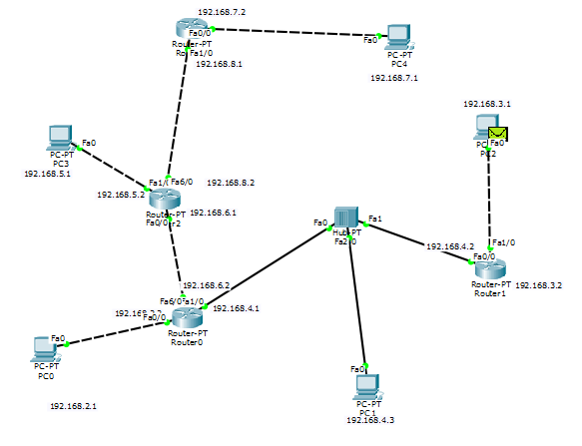

***Figure 1: Several PC connected via a Hub and Four Routers.***

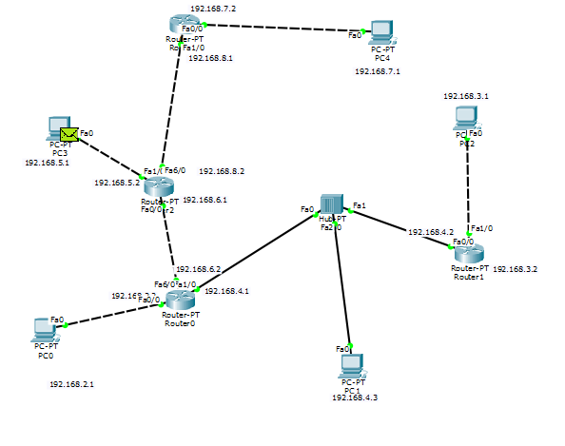

***Figure 2: Several PC connected via a Hub and Four Routers.***

**4. Receiving Acknowledgement :**

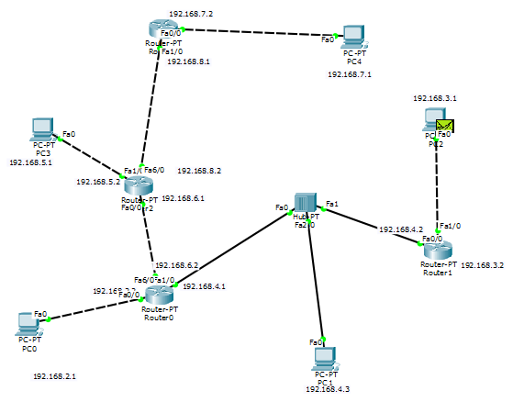

***Figure 2: Several PC connected via a Hub and Four Routers.***

**5. Configuring the PC’s :** A PC is needed to be configured before using in a network circuit. In this experiment we’ll try configuring a PC from a router via Packet Tracer software. We first connect a PC to a Router or Hub. Here we use the IP address, Subnet Mask and Default Gateway. The connection diagram is given below.

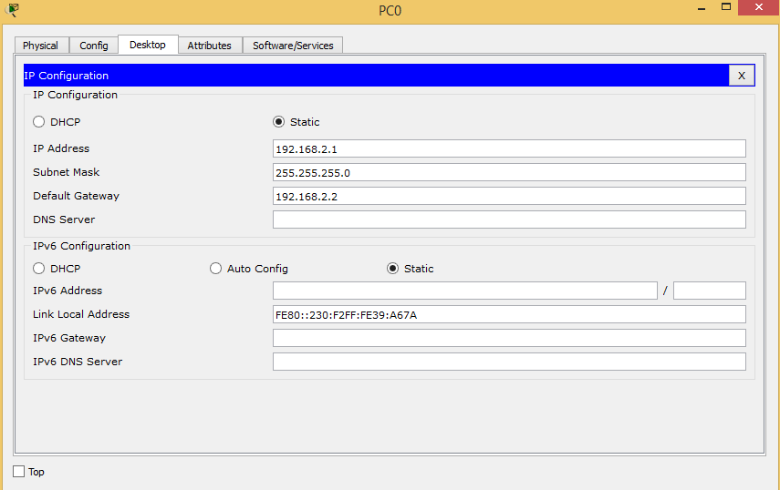 ***Figure 3: Configuring a PC***

**6. Configuring the Routers:** In this section we configure a network router. We use here IP address and Subnet Mask. The switch will be always on.

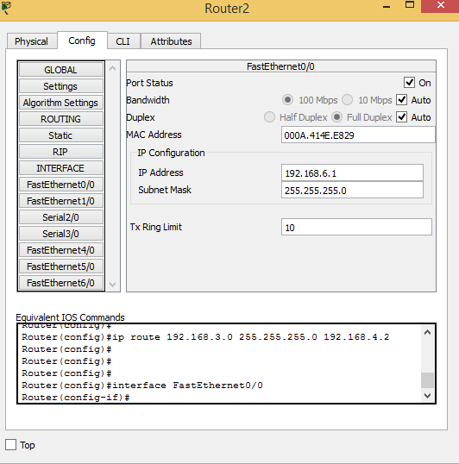

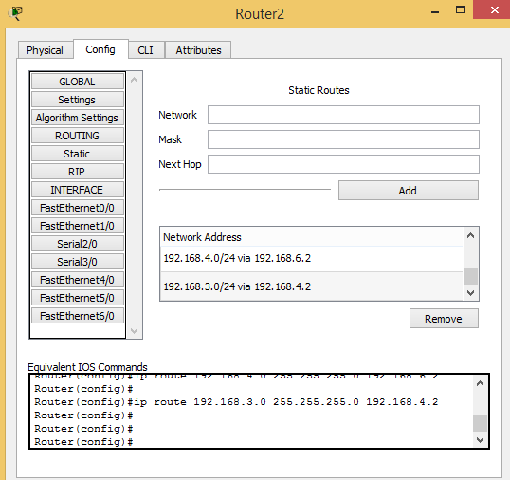

***Figure 4: Configuring a Router***

**7. Discussion**: In this experiment we’ve tested some packet transfer virtually and tested some packet transfer measurement tools. We’ve found that network latency is increased in real life because of surround noise and long distance of network cable. We also notice that the packet is passing through the PC under the network of a specific router. If a packet is passing through the Hub then it goes to the every pc but not if the packet is passing through the router.